Word Equations  outcome = explanatory + other stuff  Y = X + other stuff | Summary Tables  # compute five-number summary  favstats(~ Y, data = data_set)  # create frequency table tally(data_set$Y)  tally(~ Y, data = data_set)  # tally with logical operator  tally(~ Y < 1900, data = data_set)  # two-way frequency table  tally(Y ~ X, data = data_set) |  |  | Simulation  # sample without replacement sample(data_set, 6)  # sample with replacement resample(data_set, 10)  # randomize  # sampling distribution of b1s,  # centered on 0  sdob1 <- do(1000) *  b1(shuffle(Y) ~ X, data = data_set)  # bootstrap  # sampling distribution of b1s,  # centered on sample b1  sdob1_boot <- do(1000) *  b1(Y ~ X, data = resample(data_set)) |  |  | # return TRUE for  # middle 95% of distribution  middle(sdob1$b1, .95)  # randomize  # sampling distribution of PREs  sdopre <- do(1000) *  pre(shuffle(Y)~ X, data = data_set)  # randomize  # sampling distribution of Fs  sdof <- do(1000) *  f(shuffle(Y)~ X, data = data_set)

Basics
print("Hello world!")

# assign value to object
my_number <- 5
# combine values into vector
my_vector <- c(1, 2, 3)
# first element in vector
my_vector[1]

# arithmetic operations
sum(1, 2, 100), +, -, *, /

# logical operations

>, <, >=, <=, ==, !=, |, &
Data Frame  # view first/last six rows head(data_set)  tail(data_set)  # structure of data frame  str(data_set)  glimpse(data_set)  # select variable (a column)  data_set$Y | # select multiple variables select(data_set, Y1, Y2)  # select first row  data_set[1, ]  # select first column  data_set[, 1]  # find rows that meet condition  data_set[data_set$Y > 40]  filter(data_set, Y > 300) |  |  | # arrange rows by variable arrange(data_set, Y)  # sort in a descending order arrange(data_set, desc(Y))  # get rid of all cases with any  # missing values  na.omit(data_set) |  |  | # convert quantitative variable  # to categorical  factor(data_set$Y)  # convert categorical variable  # to quantitative  as.numeric(data_set$Y)
Fitting Models to Data  # empty model  empty_model <- lm(Y ~ NULL, data = data_set)  # use one explanatory variable  one_model <-  lm(Y ~ X, data = data_set)  # extract the best fitting b1  b1(shuffle(Y) ~ X, data = data_set)  # multivariate model  multi_model <- lm(Y ~ X1 + X2, data = data_set)  # model predictions and residuals  data_set$empty_predict <- predict(empty_model)  data_set$empty_resid <- resid(empty_model) |  | Comparing Models  pre(Y ~ X, data = data_set)  f(Y ~ X, data = data_set)  # sample F for X2  f(Y ~ X1 + X2,  data = data_set, predictor = ~X2)  # all the model comparisons that can be  # made in relation to the multivariate model generate_models(multi_model) |  |  | Evaluating Models of the DGP  # produce ANOVA table  supernova(empty_model)  supernova(multi_model)  # t-test, using pooled variance  t.test(Y ~ X, data = data_set, var.equal = TRUE)  # confidence interval  confint(lm(Y ~ X, data = data_set))  # pairwise comparison corrections:  # "Tukey","Bonferroni","none"  pairwise(my_model, correction = "Tukey")
Visualizations  gf_histogram(~ Y, data = data_set) %>%  # change labels  gf_labs(title = "Graph Title", x = "Y_Name", y = "Frequency")  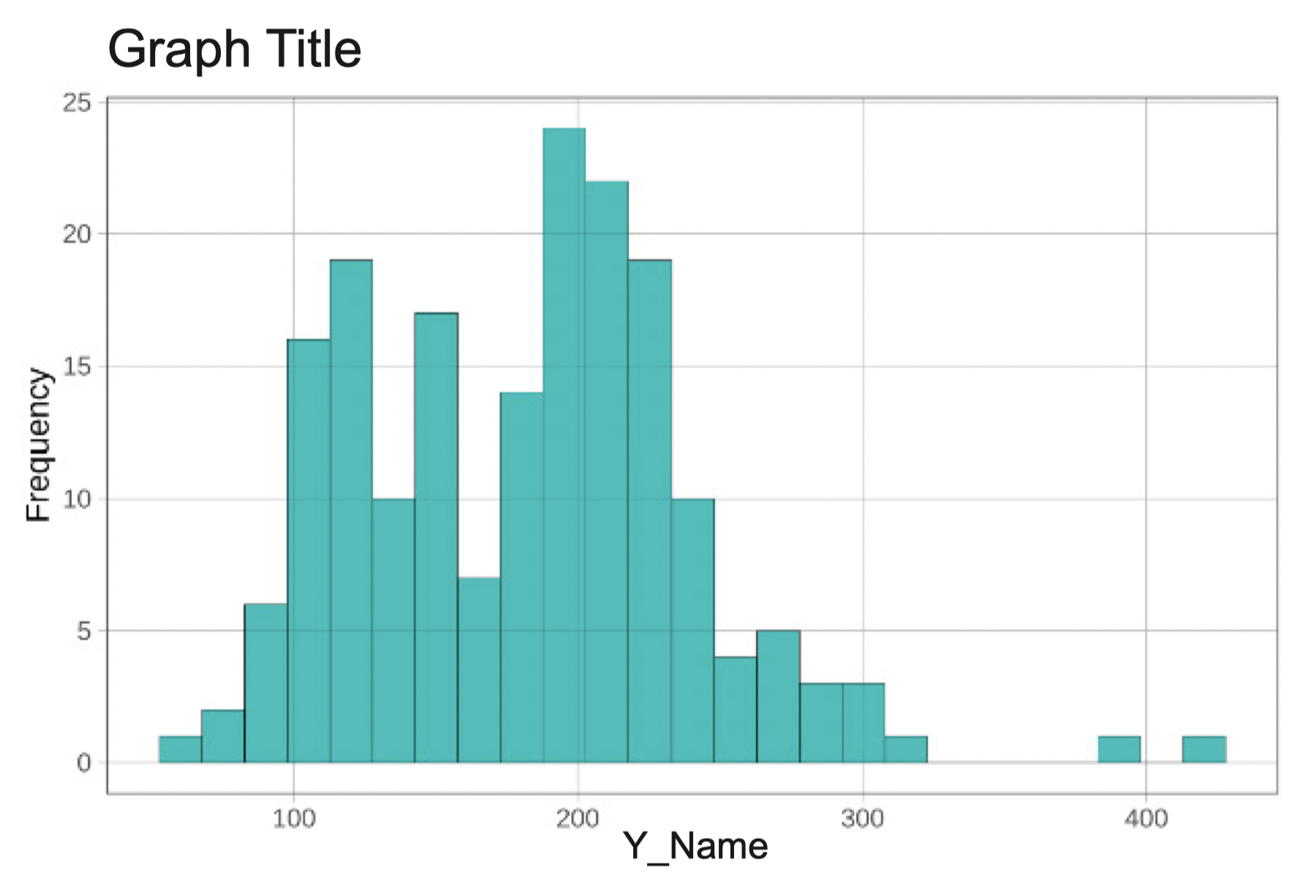  # faceted grid of histograms  gf_histogram(~ Y, data = data_set) %>%  gf_facet_grid(X ~ .)  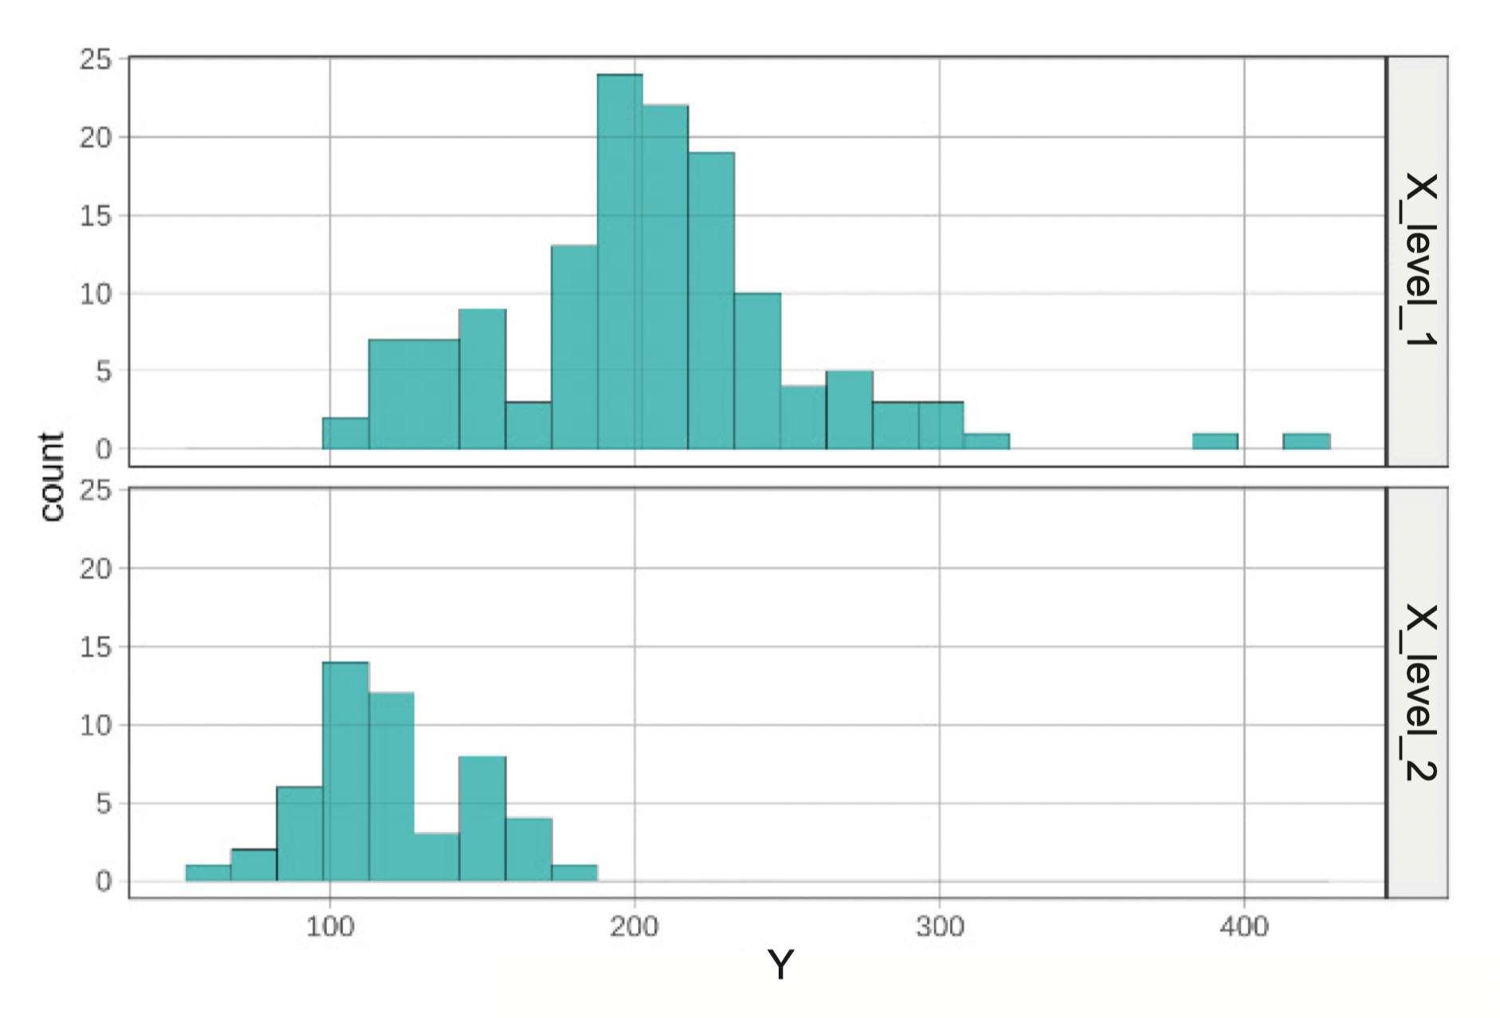  gf_histogram(~ Y, data = data_set) %>%  gf_facet_grid(X ~ Z)  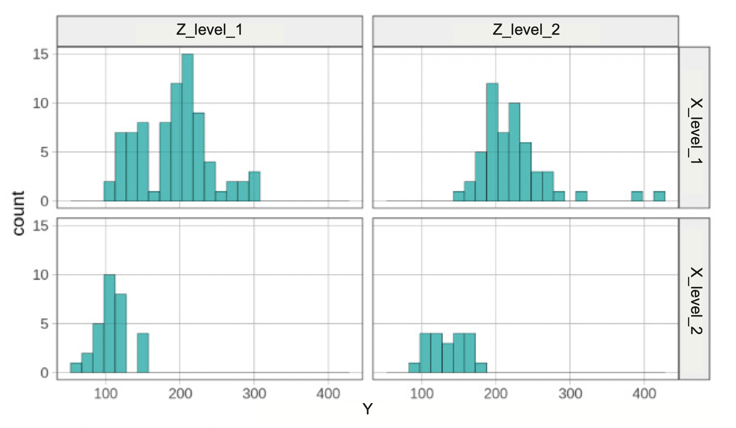 |  |  | gf_boxplot(Y ~ X, data = data_set)  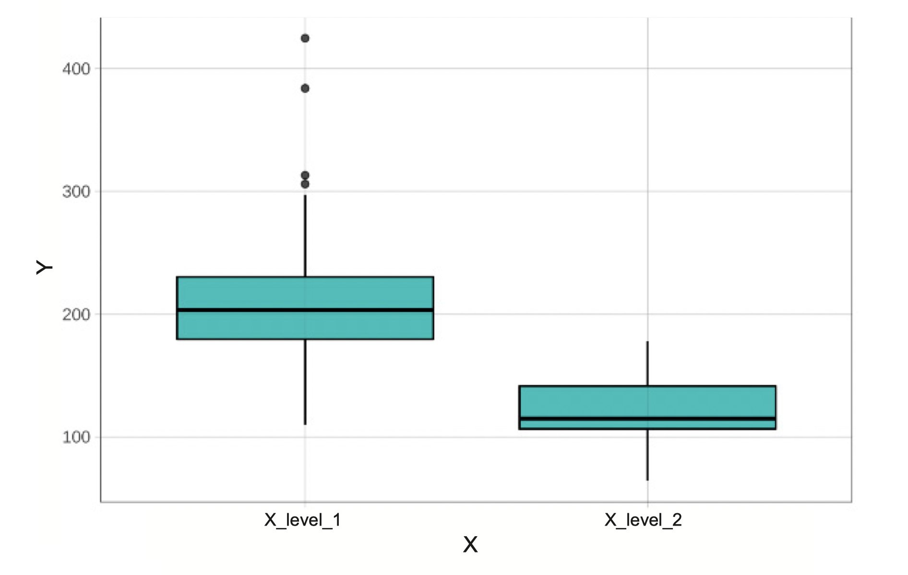  gf_jitter(Y ~ X, data = data_set)  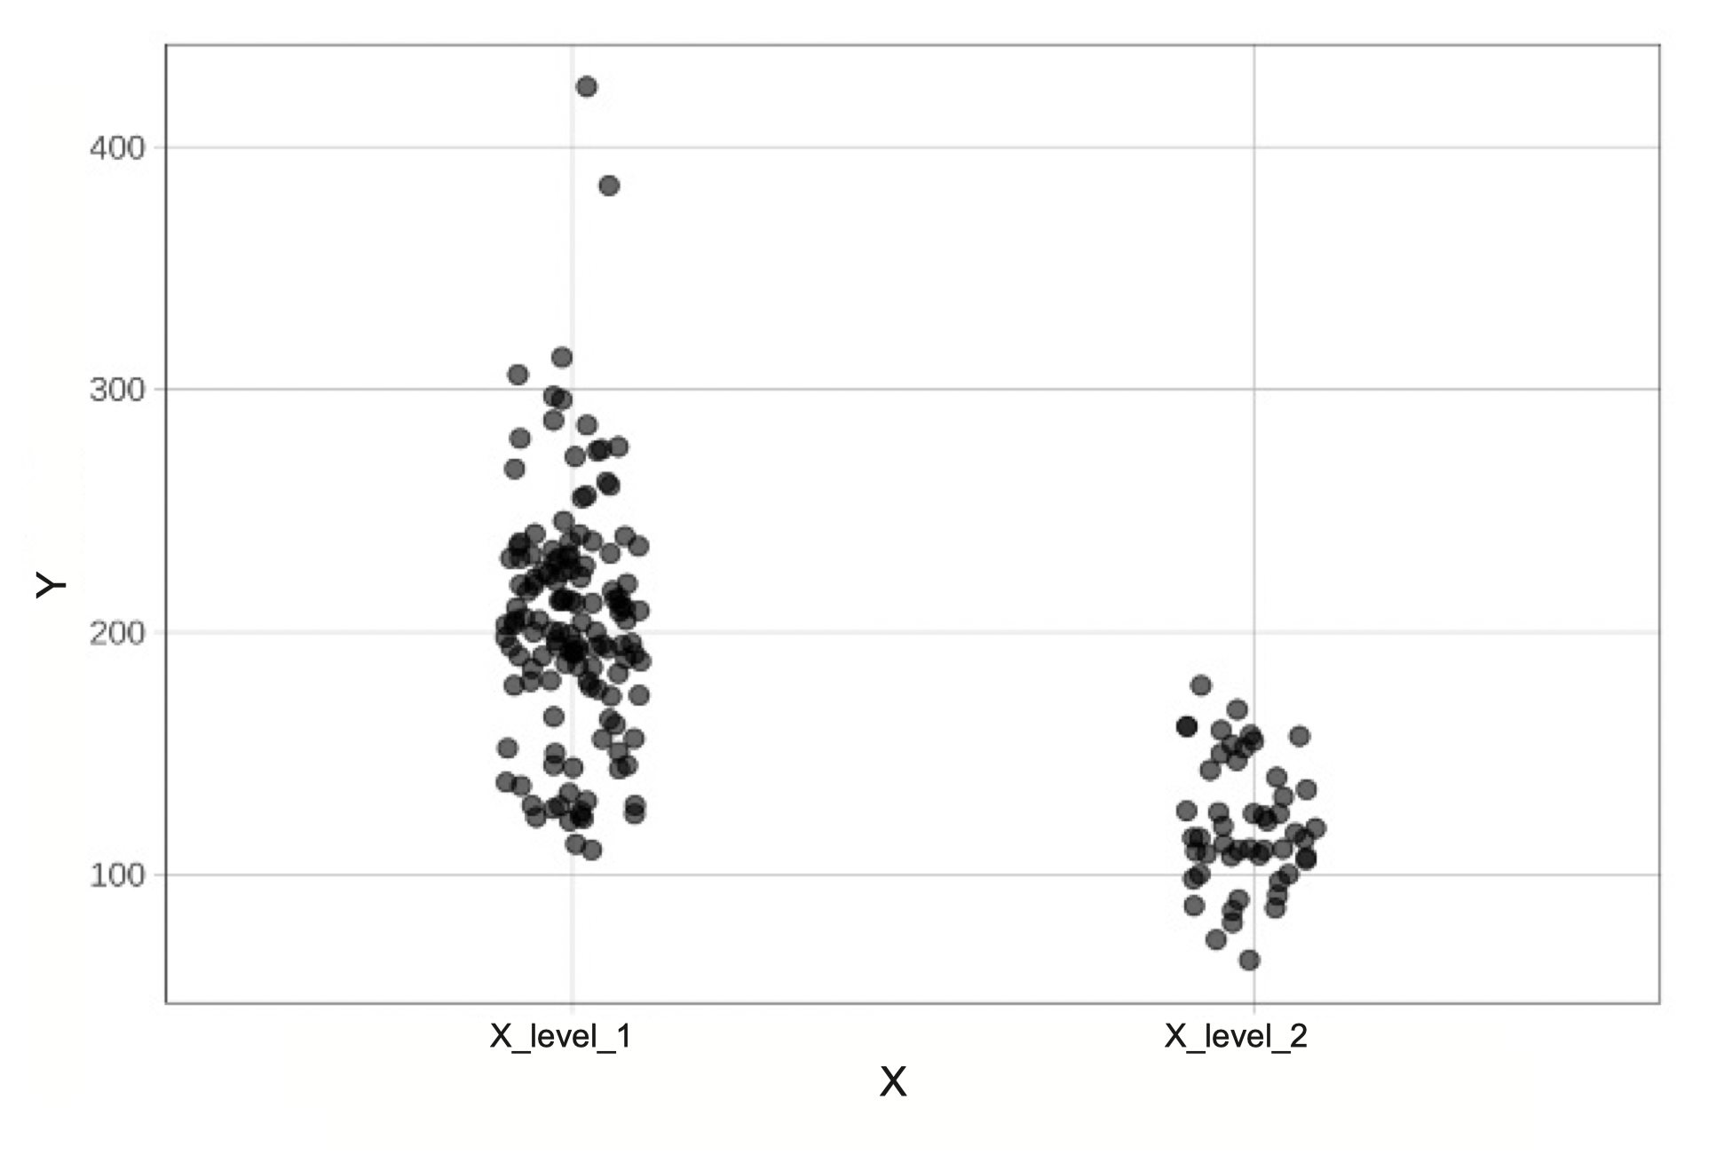  gf_point(Y ~ X, data = data_set) %>%  # add model predictions as red points  gf_point(Y ~ X , shape = 1, size = 3,  color = "firebrick") %>%  # add best fitting model as a red line  gf_model(one_model, color = “red”)  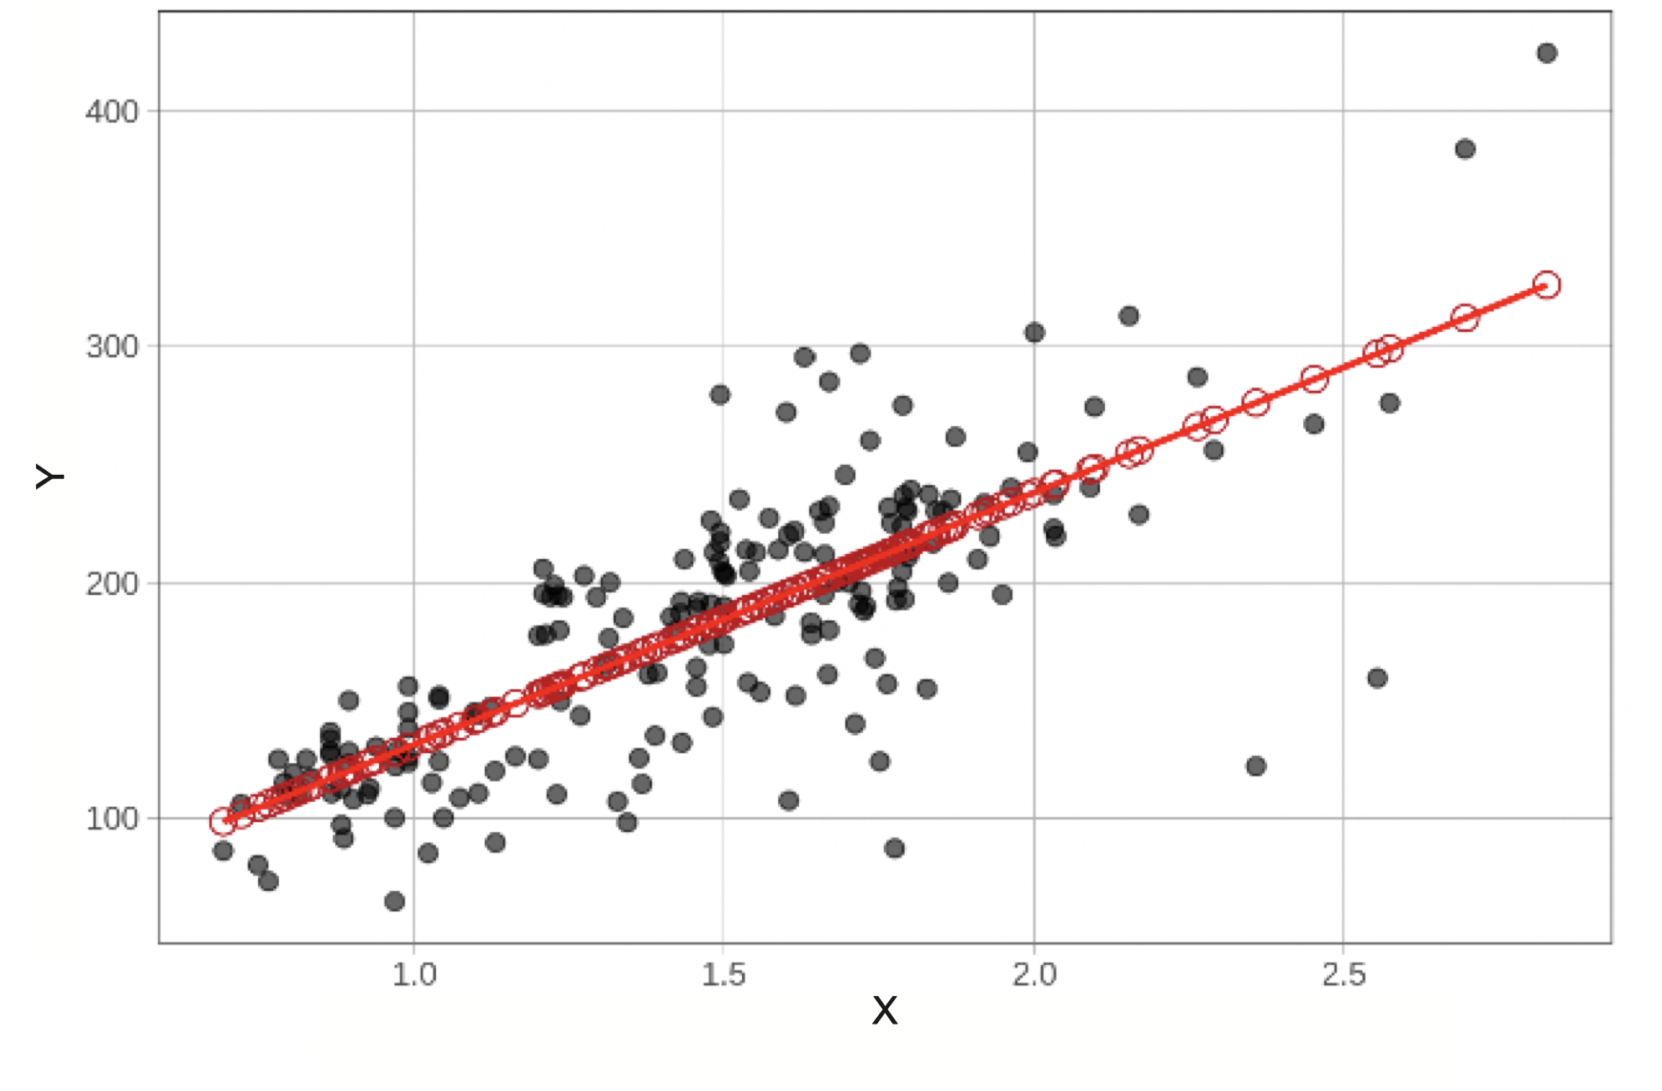 |  |  | gf_point(Y ~ X, color = ~Z,  data = data_set)  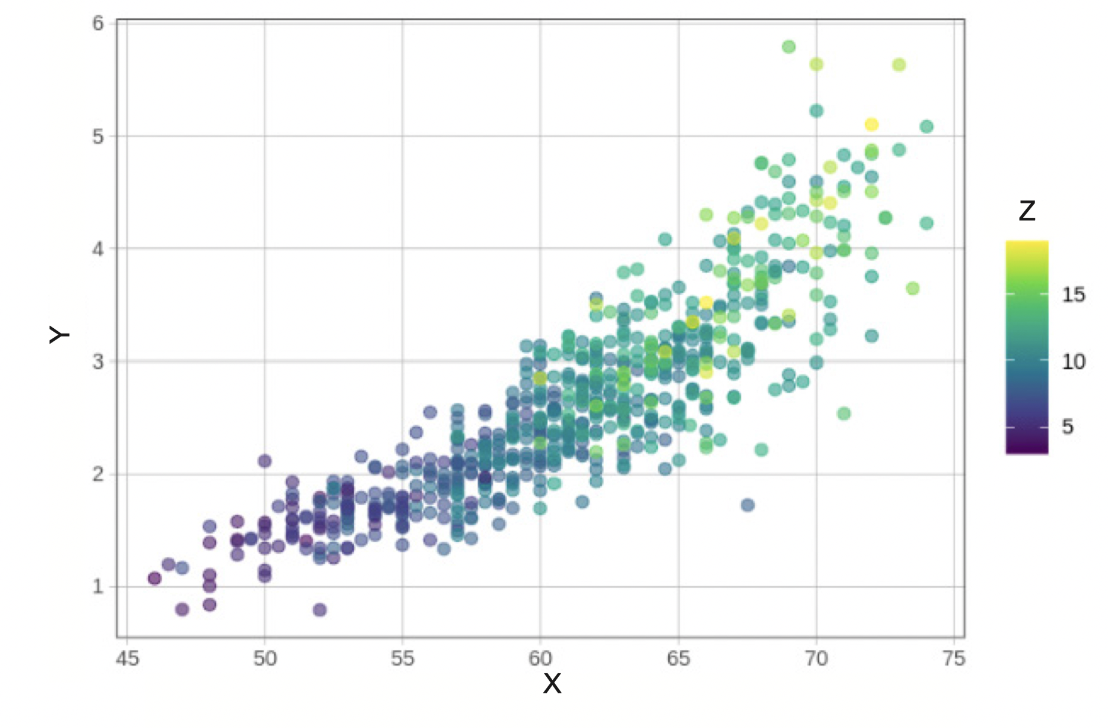  # sampling distribution of b1  gf_histogram(~b1, data = sdob1,  fill = ~middle(b1, .95)) %>%  # modify the limits on x- and y-axes  gf_lims(x = c(-12, 12), y = c(0, 70))  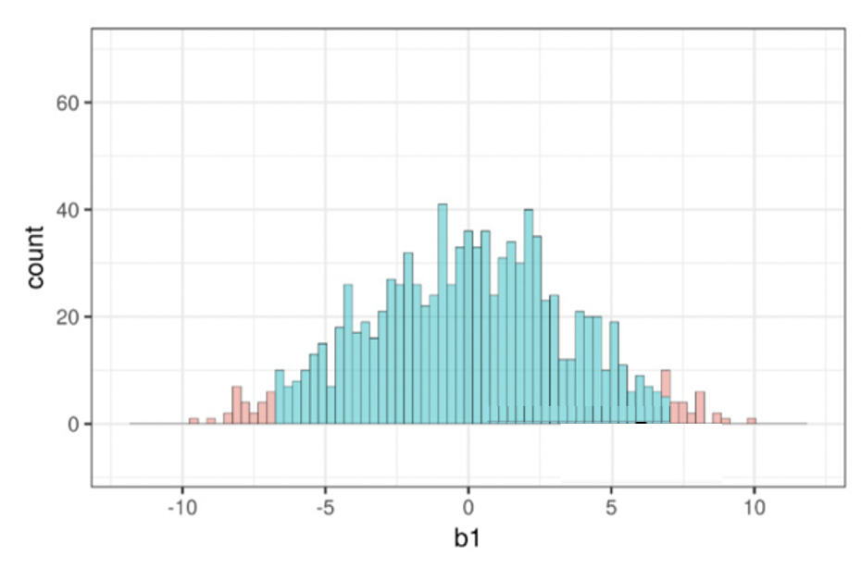  # F-distribution depicting p-value  sample_f <- f(Y ~ X, data = data_set)  xpf(sample_f, df1 = 1, df2 = 42)  